Unconfined Pedagogy

Vipasha Abrol^{1st}, Aditya Khanna^{2nd}, Arpana Kumari^{3rd}, Kumar Harsh^{4th}, Minakshi^{5th}, Pawan Yadav^{6th}
Computer Science Engineering, Chandigarh University
Chandigarh University, Mohali, Punjab

Abstract— Online teaching platforms have emerged as a powerful tool in today’s digital age, enabling educators and learners to connect and collaborate virtually. With the ongoing pandemic, the demand for online education has increased significantly, leading to the development of innovative e-learning platforms that provide a comprehensive learning experience [10]. These platforms offer a variety of features such as online classes, virtual classrooms, interactive quizzes, and assessments, allowing learners to acquire knowledge anytime and anywhere. They also provide a flexible and convenient learning environment that caters to the diverse needs of learners. This paper examines the benefits and challenges of e-learning and teaching platforms and discusses the different types of platforms available. Additionally, the paper explores the factors that contribute to the effectiveness of these platforms and discusses the future trends in e- learning and teaching platforms.

Keywords—Overcrowding; Limited diversity; Open-source platform; Active learning; Access to technology

- Introduction
The traditional in-person mode of education has some issues, such as lack of access, overcrowding, health and safety concerns, lack of flexibility, and limited diversity. Even those who find the physical system of studies perfect overall can face the drawback of missing classes, which can only be recovered by reading books or checking out notes. To solve these issues, an open-source platform is proposed that offers free education to students and helps new teachers gain experience by taking classes. This platform can be used by educational institutions to provide distance learning opportunities to students who are unable to attend in-person classes due to distance or other constraints. It can also be used for skill development, professional development, and personal development, such as learning programming, graphic design, marketing, leadership, communication, project management, new languages, new hobbies, or improving mental health. The platform offers a flexible and convenient way for clients to access educational and training opportunities that can help them achieve their goals and improve their skills and knowledge.
- PROBLEM STATEMENT
Many educational institutions and organizations are facing the challenge of delivering effective, engaging online education, and training. The limitations of traditional classroombased learning have been magnified by the pandemic, with many schools and businesses forced to transition to online learning to maintain continuity of education and training. As a result, our platform can provide an effective and engaging learning experience for students and learners of all ages and backgrounds. Our platform will be user-friendly, accessible on a range of devices, and offer a variety of interactive features to promote engagement and active learning. Additionally, our platform will offer robust analytics and reporting capabilities to help educators track student progress and adjust their teaching methods accordingly. The development of such a platform would not only address the current challenges facing educators and learners but also open new opportunities for online education and training, enabling more people to access high-quality education and training regardless of their location or circumstances.

- BACKGROUND STUDY/LITERATURE SURVEY

Throughout history, the education system has faced numerous challenges and obstacles that have affected its ability to provide equal access to education for all. In the early days, education was only available to the wealthy and elite, leaving little access for the general population. However, the rise of public education in the late 19th and early 20th century led to increased access for more people, although significant disparities based on race, gender, and socioeconomic status still existed.
The baby boomer generation of the mid-20th century put significant strain on the education system, leading to overcrowding, outdated facilities, and a shortage of qualified teachers. In the 1970s and 1980s, budget cuts and a shift towards standardized testing and accountability measures led to a decrease in funding for public schools and a narrowing of the curriculum.
In the late 20th and early 21st century, the rise of technology and the internet led to new opportunities for online education, but also exacerbated existing inequalities in access to education and resources. Online education faced challenges with ensuring quality and accountability [5].
Presently, the COVID-19 pandemic has forced many schools to shift to online learning, highlighting the digital divide and the need for more equitable access to technology and internet access [1]. Additionally, there is a growing recognition of the need for more holistic approaches to education that address social emotional learning and mental health.
Overall, the education system has faced a range of challenges throughout history, from limited access to education for the general population to issues with overcrowding, outdated facilities, and budget cuts. The rise of technology has brought new opportunities but also new challenges, including ensuring quality and accountability in online education. The COVID19 pandemic has highlighted the digital divide and the need 2 for more equitable access to technology [4]. There is a growing recognition of the need for more holistic approaches to education that address social-emotional learning and mental health, indicating a shift towards a more well-rounded and inclusive education system.

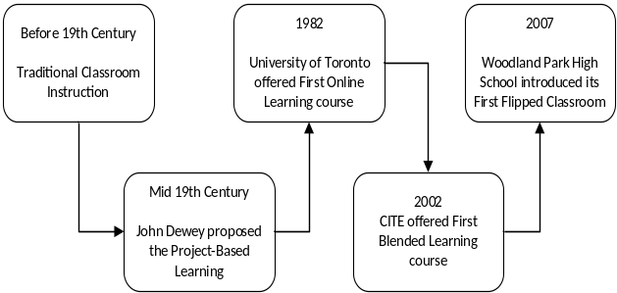

Fig-1-Block Diagram showing changes in Education System
- Proposed Solution
Based on the existing solutions in the current education system, we propose a comprehensive online learning platform that combines the strengths of various approaches to deliver an effective and engaging learning experience. Our proposed solution incorporates the following key elements:
- Blended Learning Approach: Our platform adopts a blended learning approach, combining the benefits of traditional classroom instruction and online learning [11]. Students will have the opportunity to attend physical classes for face-to-face interaction with teachers and peers, as well as access digital resources and coursework online. This hybrid approach provides flexibility and personalized learning experiences.
- Interactive and Multimedia Content: We emphasize the use of interactive and multimedia content to enhance engagement and comprehension. Video lectures, simulations, virtual labs, and interactive quizzes will be integrated into the platform to facilitate active learning and provide hands-on experiences.
- Our Project-Based Learning Opportunities: Our platform will incorporate project-based learning methodologies, allowing students to work on real-world projects and apply their knowledge in practical settings. This approach fosters collaboration, critical thinking, and problem-solving skills.
- Our Learning Management System (LMS): A robust LMS will be an integral part of our platform, providing a centralized hub for course management, content delivery, and assessment. Educators can easily create and manage courses, enroll students, facilitate discussions, and utilize grading tools. The LMS will also offer analytics and reporting features to track student progress and provide insights for instructional improvement.
- Virtual Classroom Capabilities: Real-time interaction between teachers and students will be facilitated through virtual classroom features. Video conferencing, chat functions, and shared whiteboards will enable synchronous learning experiences, where teachers can deliver live lectures, engage in discussions, and conduct interactive activities.
- Asynchronous Learning Options: To accommodate diverse learning needs and schedules, our platform will offer asynchronous learning options. Students can access pre-recorded lectures, readings, and assignments, allowing for self-paced learning and flexibility.
- User-Friendly Interface and Accessibility: Our platform will prioritize a user-friendly interface that is accessible on various devices, including smartphones, tablets, and computers. This accessibility ensures that learners can access educational content anytime and anywhere, promoting inclusivity and equal access to education.
- Bibliography
- Traditional Classroom Instruction: This is the traditional method of teaching, where a teacher delivers lessons in a classroom setting. This method allows for face-to-face inter- action between the teacher and the students and encourages active participation and discussion [2].
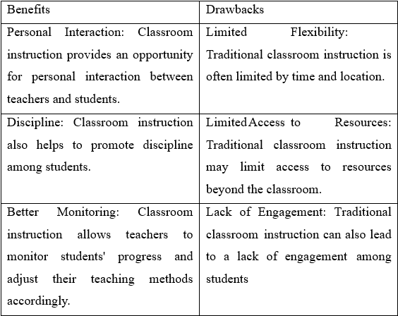

Table-1-Showing Benefits and Drawbacks of Traditional Classroom Instruction
- Online Learning Platforms: These are virtual platforms that allow students to learn at their own pace from anywhere in the world.
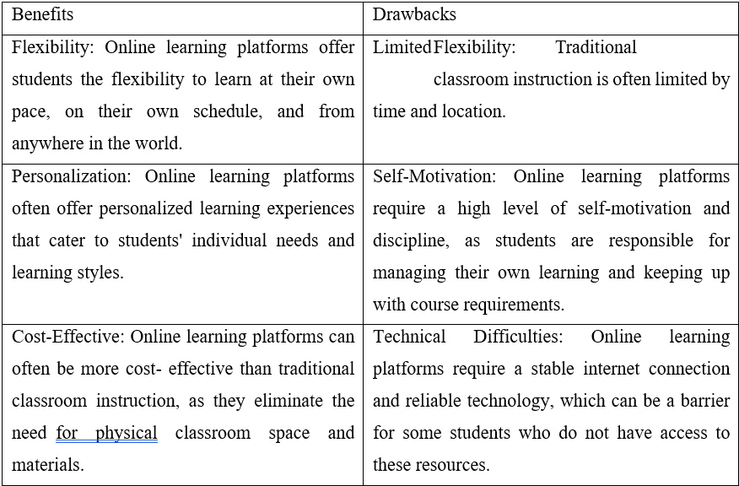
Table-2-Showing Benefits and Drawbacks of Online Learning Platforms

- Blended Learning: This is a hybrid approach that combines traditional classroom instruction with online learning [11].
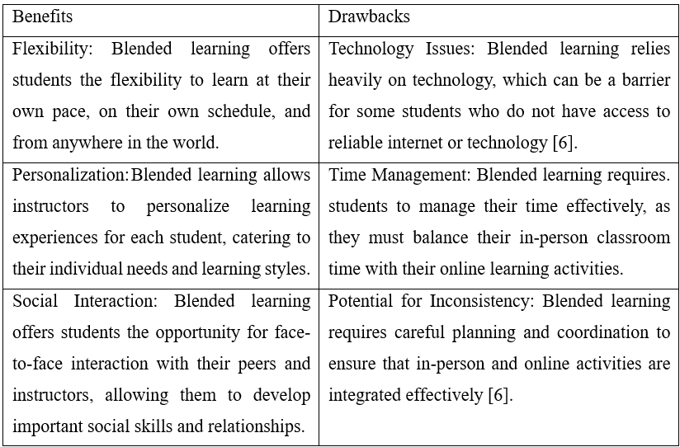
Table-3-Showing Benefits and Drawbacks of Blended Learning
- Flipped Classroom: Another hybrid approach where students learn content online outside of class and then attend class to apply their learning through interactive activities and discussions [7].
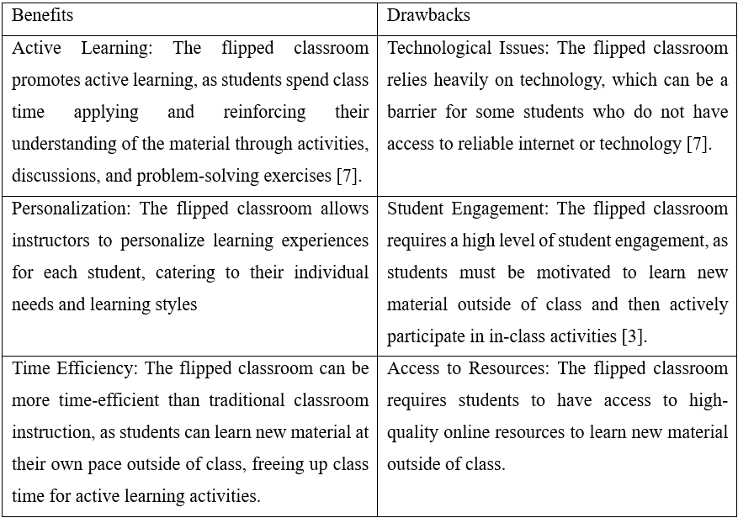
Table-4-Showing Benefits and Drawbacks of Flipped Classroom

- Project-Based Learning: This is a teaching method where students work on real-world projects to learn new concepts and skills [10].
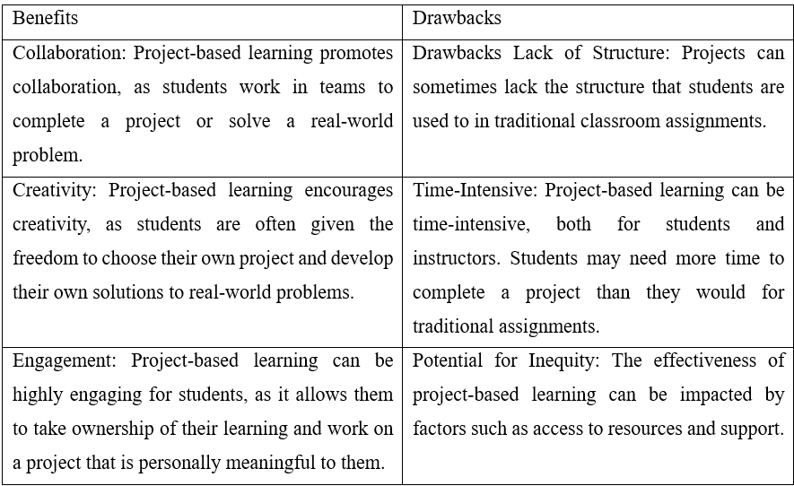
Table-5-Showing Benefits and Drawbacks of Project-Based Learning

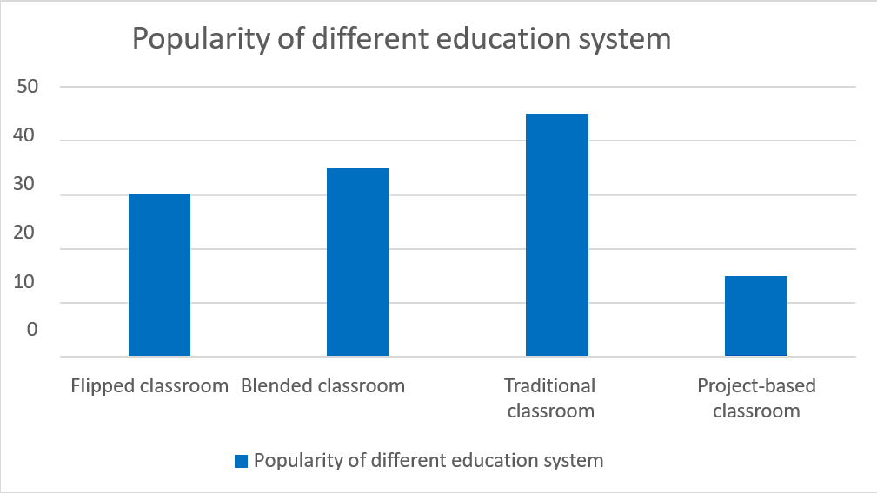

Fig-2-Graph showing popularity of different Education Systems

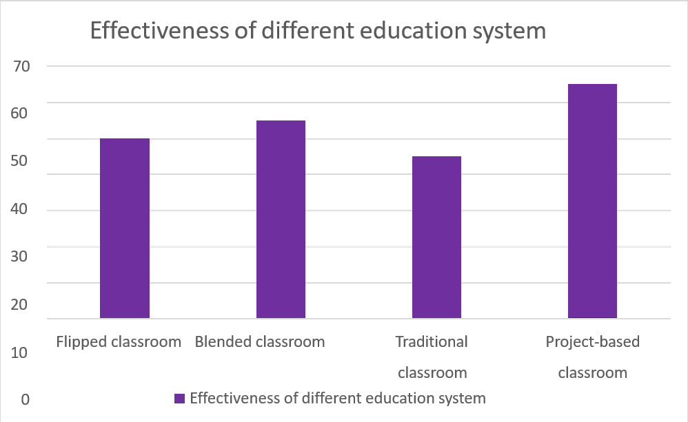

Fig-3-Graph showing effectiveness of different Education Systems
- Analysis of Important Features
- Personalization: It involves creating a customized learning path for each student based on their strengths, weaknesses, learning styles, and goals. Personalization can be achieved through a variety of methods, such as adaptive learning technology, differentiated instruction, project-based learning, and individualized tutoring. The goal of personalization is to increase student engagement and motivation, improve learning outcomes, and provide students with a more relevant and meaningful learning experience.
- Flexibility: All the teaching methods mentioned offer some level of flexibility in terms of scheduling and location. accommodating of this curiosity allowing lessons to have a much looser structure, letting discussions and thoughts play out and following them to see where they go. Flexible learning can include online courses, self-paced modules, or blended learning approaches that combine online and face-to-face instruction. This approach allows students to balance their education with other commitments such as work or family responsibilities, and to access learning opportunities from anywhere in the world. Additionally, flexibility allows educators to tailor their teaching methods to suit the individual needs and learning styles of each student.
- Technology: Technology plays a significant role in all these teaching methods, whether it's in the form of online learning platforms, flipped classroom, or blended learning. Technology can be used to enhance and improve various aspects of teaching and learning, including personalization, collaboration, access to information, and communication.
- Active Learning: All these teaching methods promote active learning, where students are actively engaged in the learning process through activities, discussions, and problem-solving exercises. In active learning, students participate in various activities, discussions, and problem-solving exercises, allowing them to explore, apply, and integrate new knowledge. This approach promotes critical thinking, problem-solving skills, and encourages students to take ownership of their learning. It is often contrasted with traditional lecture-based teaching methods, where students are passive recipients of information.
- Student Engagement: Student engagement is a key focus in all these teaching methods, where students are encouraged to take ownership of their learning and become active participants in the learning process. It is a process where students are motivated to learn, take ownership of their learning, and become active participants in the learning process. In an engaged learning environment, students are more likely to develop critical thinking, problem-solving, and collaboration skills, and are more likely to retain and apply the knowledge they acquire. Engaged students are also more likely to feel a sense of accomplishment and satisfaction with their learning.
- Collaboration: Collaboration among students and with teachers is encouraged in all these teaching methods, where students work together on projects, activities, and discussions. Collaboration involves students working together in groups, pairs or with teachers to solve problems, complete tasks, and learn from each other's perspectives and experiences. Collaboration encourages communication, critical thinking, and problem-solving skills and is often used as a key component in project-based learning and other active learning methods. It helps students develop social skills, such as teamwork, leadership, and empathy, and prepares them for real-world situations where they will need to work effectively with others to achieve success.
- Promoting student engagement: Creating a learning environment and teaching approach that encourages students to actively participate and become invested in their own learning. When students are engaged, they are more likely to retain information and develop a deeper understanding of the material being taught. Engaged students are also more likely to participate in classroom discussions, collaborate with their peers, and apply their learning in real-world situations. This can be achieved through various teaching methods, such as hands-on activities, interactive discussions, and project-based learning, that promote active learning and student-centred instruction.
- Catering to individual learning styles: The teaching method is tailored to match the preferences and strengths of individual students. This can involve adapting instructional strategies, materials, and assessment methods to suit the different ways that students learn. For example, some students may prefer visual aids like diagrams or videos, while others may prefer more hands-on activities or group work. By catering to individual learning styles, educators can help ensure that all students are able to learn effectively and reach their full potential.
- Providing regular feedback: Giving students constructive and timely comments on their work, progress, and performance. It helps students understand their strengths and weaknesses, and identify areas that need improvement. Regular feedback allows teachers to track students' progress and adjust their teaching methods accordingly, which can ultimately lead to better learning outcomes. Feedback can be provided in different forms such as written comments, verbal feedback, rubrics, self-assessment, peer review, and more. The goal of providing regular feedback is to encourage students to learn from their mistakes and continue to improve.
- Encouraging collaboration: Promoting teamwork and cooperation among students. This can involve group projects, discussions, and activities that require students to work together to achieve a common goal. Collaboration can help students develop important skills such as communication, problem-solving, and leadership, and can also help to build a sense of community in the classroom. Encouraging collaboration can be particularly beneficial for students who may struggle with independent work or who may feel isolated in the classroom.
- Adapting to technology: Incorporating technology into the teaching and learning process. This can include using digital tools such as online platforms, educational software, and multimedia resources to enhance the educational experience. It can also involve using technology to facilitate communication and collaboration between teachers and students, such as through video conferencing or instant messaging. Adapting to technology can help to make the learning process more interactive, engaging, and accessible to students with different learning styles and abilities.
- Promoting equity: Ensuring that every student has access to the resources, support, and opportunities they need to succeed academically, regardless of their background, identity, or ability. This includes addressing and reducing disparities in educational outcomes among different student populations, such as those based on race, ethnicity, socioeconomic status, language proficiency, or special needs. It also involves creating a safe and inclusive learning environment where all students feel valued and respected, and where their diversity is celebrated as a strength. Promoting equity requires intentional and proactive efforts to identify and address systemic barriers to educational opportunities and to provide targeted support for marginalized students.

- Conclusions

Our project is a humble yet powerful endeavor that efficiently manages project work and satisfies the needs of an online teaching platform. With user-friendly coding practices, we developed a comprehensive software package for students and mentors. The objective was to provide a seamless interface and advanced features for reasonable estimates, course planning, and skill acquisition within a limited time frame. Regular updates to the user interface were prioritized as our user base grew. We focused on a thorough project description, clear objectives, purpose, scope, and problem refinement. Detailed requirement specifications outlined website actions and user-friendly features. Emphasis was placed on user interface design and website security. Through successful implementation and rigorous testing, we ensured reliability and functionality. Our project effectively manages projects and serves as a valuable online teaching platform. In conclusion, our user-friendly software package facilitates efficient project management and addresses online teaching needs. With careful planning, problem refinement, and attention to detail, we have created a robust solution that empowers users to effectively manage projects and enhance learning experiences.
Acknowledgment

We would like to express our heartfelt appreciation to everyone who contributed to the completion of this research paper. First and foremost, we thank our supervisor Professor Vipasha Abrol for their guidance and support throughout the research process. We are grateful to Chandigarh University for providing resources and facilities for this study. Our sincere thanks go to the participants for their valuable time and willingness to share their insights. We acknowledge the support and input of our colleagues and friends, as well as the understanding and encouragement of our families. We extend our gratitude to all those who played a part, big or small, in the successful completion of this research. Thank you for your invaluable support.
Team Unconfined Pedagogy,

References
- T. Supriyatno and F. Kurniawan, "A New Pedagogy and Online Learning System on Pandemic COVID 19 Era at Islamic Higher Education," 2020 6th International Conference on Education and Technology (ICETislsd), Malang, Indonesia, 2020, pp. 7-10, doi: 10.1109/ICET51153.2020.9276604.
- Wilson, Kofi Bentum. "Impact of emerging technologies on teacher education: experiences of teacher trainees." Journal of Education and Practice 5, no. 28 (2014): 168-176.
- Holm, Lene Berge, Andre Rognes, and Fredrik Andreas Dahl. "The FLIPPED STEP study: A randomized controlled trial of flipped vs. traditional classroom teaching in a university-level statistics and epidemiology course." International Journal of Educational Research Open 3 (2022): 100197.
- Halil, Nur Ihsan. "The effectiveness of using edmodo as an online learning platform in Covid-19." Jurnal Penelitian dan Pengkajian Ilmu Pendidikan: e-Saintika 4, no. 3 (2020): 284ko-298.
- Spanbauer, Stanley J., and Jo Hillman. A Quality System for Education: Using Quality and Productivity Techniques To Save Our Schools. ASQC Quality Press, 611 East Wisconsin Avenue, Milwaukee, WI 53202, 1992.
- M. C. Wijanto, O. Karnalim, M. Ayub, H. Toba and R. Tan, "Transitioning from Offline to Online Learning: Issues from Computing Student Perspective," 2021 IEEE Global Engineering Education Conference (EDUCON), Vienna, Austria, 2021, pp. 1137-1142, doi: 10.1109/EDUCON46332.2021.9453996.
- McCue, Rich. “Exploring the learning outcomes of a flipped learning methodology for post-secondary information literacy students: a mixed methods approach.” (2016).
- W. A. Halang, "Real-time systems education: what is really essential?," Proceedings Real-Time Systems Education III, Poznan, Poland, 1998, pp. 156-159, doi: 10.1109/RTSE.1998.766529.
- Z. Ding and R. Li, "Design of Web-Based Research E-learning Platform," 2010 International Conference on e-Education, e-Business, e-Management and e-Learning, Sanya, China, 2010, pp. 131-134, doi: 10.1109/IC4E.2010.89.
- Zafirov, Ch. "New challenges for the project based learning in the digital age." Trakia Journal of Sciences 11, no. 3 (2013): 298-302.
- Capone, Roberto, Patrizia De Caterina, and Giustina Anna Gerarda Mazza. "Blended learning, flipped classroom and virtual environment: challenges and opportunities for the 21st century students." Edulearn17 Proceedings (2017): 10478-10482.

